Advanced Bioinformatics 2019 assessment

m1700635

05/04/2021

Question 3.1. Using the sum() function and : operator, write an expression in the code snippet to evaluate the sum of all integers between 5 and 55.

#How to use sum integers and numbers in R programming: #There are different ways to do so: #I will use sum command to sum every number in the range 5->55. The answer is 1530 #sum(5:55)

sum(5:55)

## [1] 1530

#We can also find the sum from a few numbers, which determined between 5 and 55 sum(5,6,7,8,9,10,11,12,13,14,15,16,17,18,19,20,21,22,23,24,25,26,27,28,29,30,31,32,33,34,35,36,37,38,39,40,41,42,43,44,45,46,47,48,49,50,51,52,53,54,55)

sum(5,6,7,8,9,10,11,12,13,14,15,16,17,18,19,20,21,22,23,24,25,26,27,28,29,30,31,32,33,34,35,36,37,38,39,40,41,42,43,44,45,46,47,48,49,50,51,52,53,54,55)

## [1] 1530

#We can generate a sequence of numbers either named #(specified) using from, by, and to: #seq(5,55,1)

seq(5,55,1)

## [1] 5 6 7 8 9 10 11 12 13 14 15 16 17 18 19 20 21 22 23 24 25 26 27 28 29

## [26] 30 31 32 33 34 35 36 37 38 39 40 41 42 43 44 45 46 47 48 49 50 51 52 53 54

## [51] 55

#or unnamed (not specified) using: #seq(by=1, from=5, to=55)

seq(by=1, from=5, to=55)

## [1] 5 6 7 8 9 10 11 12 13 14 15 16 17 18 19 20 21 22 23 24 25 26 27 28 29

## [26] 30 31 32 33 34 35 36 37 38 39 40 41 42 43 44 45 46 47 48 49 50 51 52 53 54

## [51] 55

#Since the vector is an ordered list of numbers, we have to use the command #sum x <- c(5:55);sum(x)

sum(x <- c(5:55))

## [1] 1530

Question 3.2. Write a function called sumfun with one input parameter, called n, that calculates the sum of all integers between 5 and n. Use the function to do the calculation for n = 10, n = 20, and n = 100 and present the results.

sumfun <- **function**(n) {sum(5:n)}

sumfun(10)

## [1] 45

sumfun(20)

## [1] 200

sumfun(100)

## [1] 5040

Question 3.3. The famous Fibonacci series is calculated as the sum of the two preceding members of the sequence, where the first two steps in the sequence are 1, 1. Write an R script using a for loop to calculate and print out the first 12 entries of the Fibonacci series.

#to calculate the Fibonacci series with n values: #fib <- function(n) #or fib <-numeric(n)

fib <-numeric(12)

#fib of the first number is 1 #fib[1] <- 1

fib[1] <- 1

#fib of the second number is 2 #fib[2] <- 1

fib[2] <- 1

#the loop starts from the third number; that means: #i = 3

i = 3

#we have to repeat the loop to the 12th number of fib

fib <- **function**(n) { *# function for calculating fibonnaci of a vector with n values*

fib <-numeric(n)

fib[1] <- 1

*# fib of the first number is 1*

fib[2] <- 1

*# fib of the second number is 2*

i = 3

*# start the loop at the third element*

**while** (i <= n) { *# repeat the loop for the 12th number of fib*

fib[i]=fib[i - 1] + fib[i - 2]

i<- i + 1

}

**return**(fib) *# return the modified vector*

}

fib(12)

## [1] 1 1 2 3 5 8 13 21 34 55 89 144

Question 3.4. With the mtcars dataset bundled with R, use ggplot to generate a box of miles per gallon (in the variable mpg) as a function of the number of gears (in the variable gear). Use the fill aesthetic to colour bars by number of gears.

str(mtcars)

## 'data.frame': 32 obs. of 11 variables:

## $ mpg : num 21 21 22.8 21.4 18.7 18.1 14.3 24.4 22.8 19.2 ...

## $ cyl : num 6 6 4 6 8 6 8 4 4 6 ...

## $ disp: num 160 160 108 258 360 ...

## $ hp : num 110 110 93 110 175 105 245 62 95 123 ...

## $ drat: num 3.9 3.9 3.85 3.08 3.15 2.76 3.21 3.69 3.92 3.92 ...

## $ wt : num 2.62 2.88 2.32 3.21 3.44 ...

## $ qsec: num 16.5 17 18.6 19.4 17 ...

## $ vs : num 0 0 1 1 0 1 0 1 1 1 ...

## $ am : num 1 1 1 0 0 0 0 0 0 0 ...

## $ gear: num 4 4 4 3 3 3 3 4 4 4 ...

## $ carb: num 4 4 1 1 2 1 4 2 2 4 ...

**library**(ggplot2)

## Warning: package 'ggplot2' was built under R version 4.0.5

ggplot(data = mtcars, aes(x= as.factor(gear), y= mpg)) + geom_boxplot(aes(fill= as.factor(gear) )) + ggtitle(" Box of Miles per Gallon(mpg) as a Function of Gears")

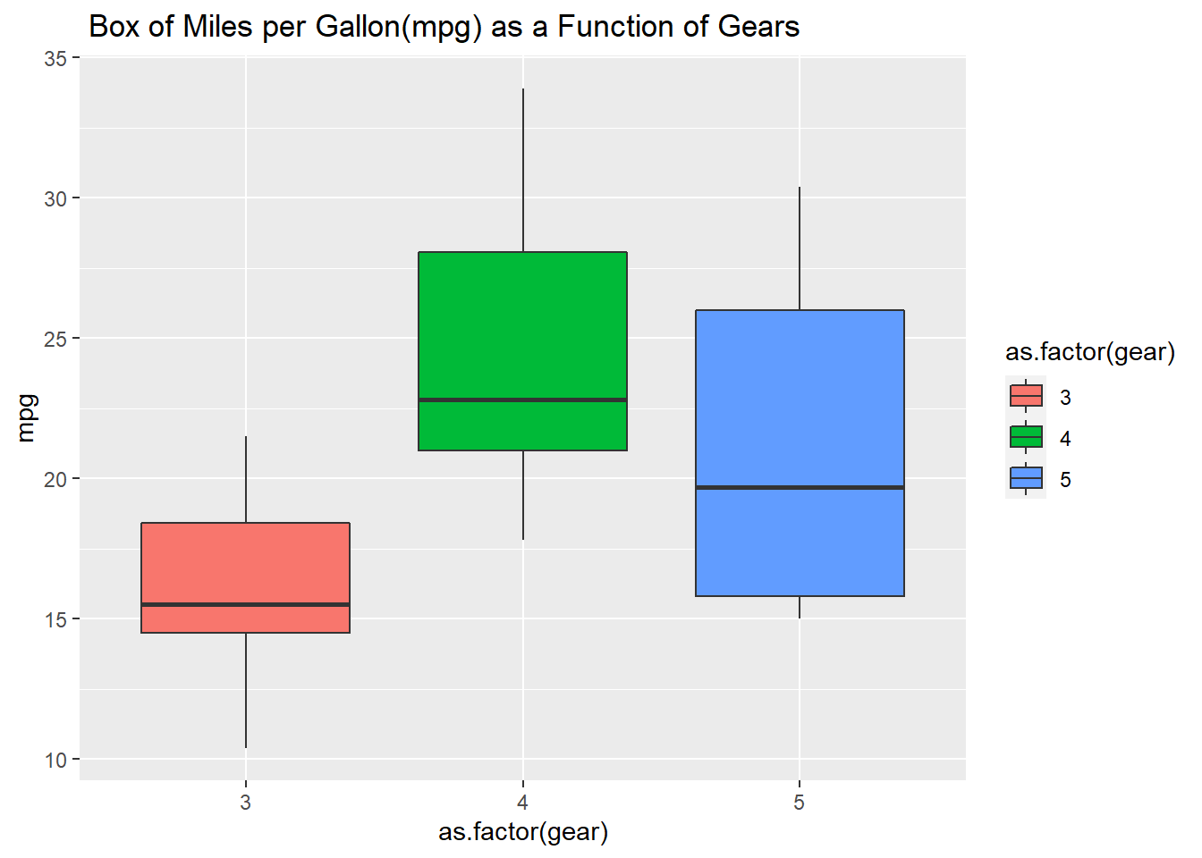

Question 3.5. Using the cars dataset and the function lm, fit a linear relationship between speed and breaking distance in the variable distance. What are the fitted slope and intercept of the line, and their standard errors? What are the units used for the variables in the dataset?

#First, we have to set variable for x and y axises. #then, we can set linear model formula and get the summary of model

y <- cars $dist; x <- cars $speed;

model <- lm(formula = "y ~ x")

summary(model)

##

## Call:

## lm(formula = "y ~ x")

##

## Residuals:

## Min 1Q Median 3Q Max

## -29.069 -9.525 -2.272 9.215 43.201

##

## Coefficients:

## Estimate Std. Error t value Pr(>|t|)

## (Intercept) -17.5791 6.7584 -2.601 0.0123 *

## x 3.9324 0.4155 9.464 1.49e-12 ***

## ---

## Signif. codes: 0 '***' 0.001 '**' 0.01 '*' 0.05 '.' 0.1 ' ' 1

##

## Residual standard error: 15.38 on 48 degrees of freedom

## Multiple R-squared: 0.6511, Adjusted R-squared: 0.6438

## F-statistic: 89.57 on 1 and 48 DF, p-value: 1.49e-12

#To answer these questions from the coefficient dataset provided above, we can determine: #The fitted slope is 3.9324 #The intercept of the line is -17.5791 #Their standard errors are 6.7584 (for intercept (dist)) #and 0.4155 (for X (speed)) #The units used for the variables in the dataset to #measure the speed and breaking distance is feet

Question 3.6. Use ggplot to plot the data points from Task 6 and the linear fit.

#we have to download: library(ggplot2) to help us run the plots

**library**(ggplot2)

#we have to identify the variables to run the plots

qplot(speed, dist, data = cars, geom ="point")

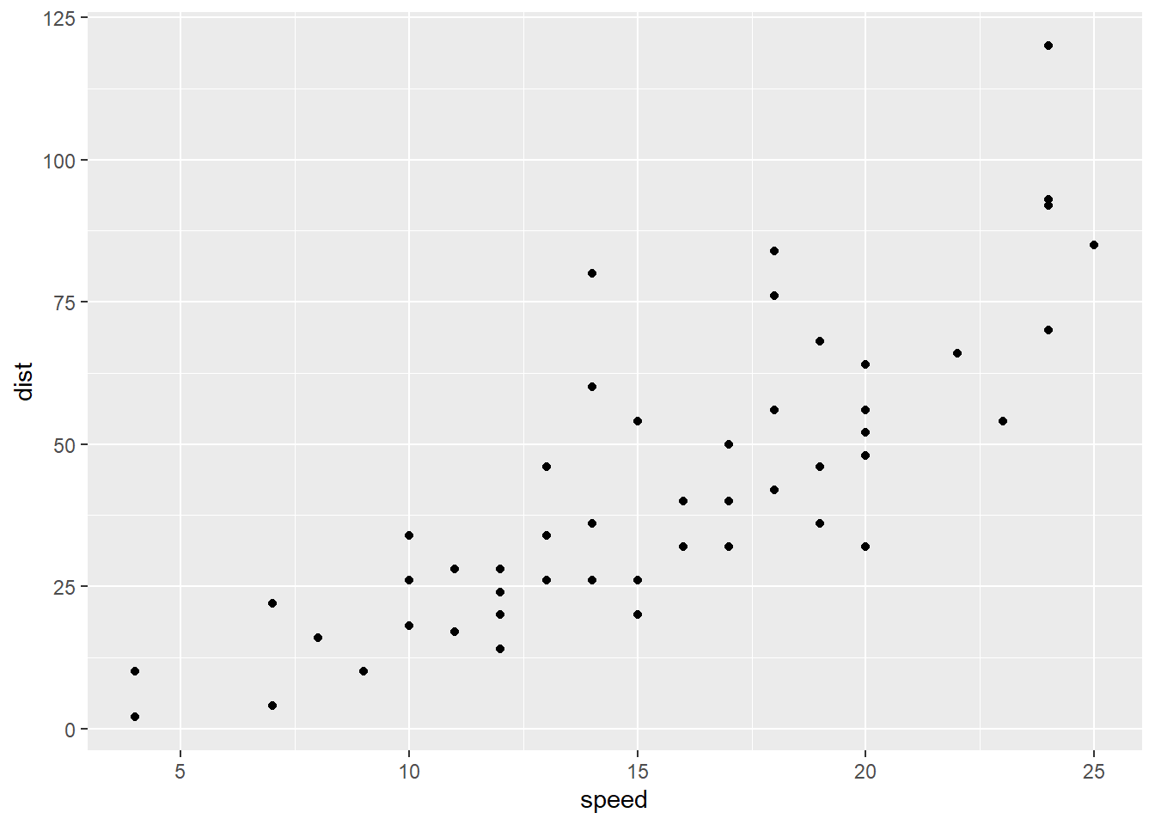

qplot(speed, dist, data = cars, geom ="point") + geom_smooth(method= "lm", se = FALSE)

## `geom_smooth()` using formula 'y ~ x'

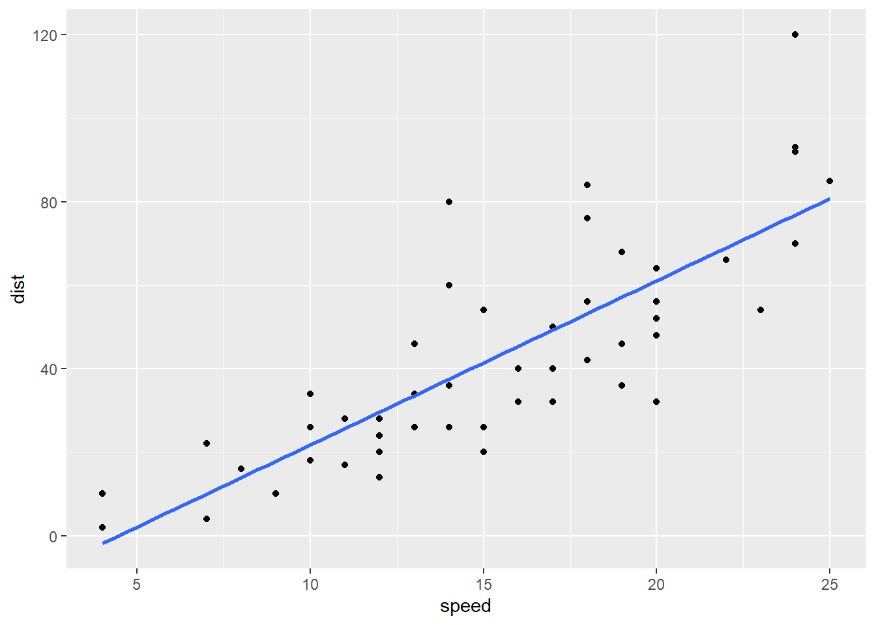

#we have to create new variables named ggplot_new and add a title, x, and y lables it to the previous plot

ggplot <- ggplot(data = cars, aes(x= speed, y=dist)) + geom_point() + geom_smooth(method = "lm",formula = "y ~ x")

ggplot_new <- ggplot + ggtitle ("Linear model of the relationship between breaking distance(dist) and speed")+ xlab("speed(milesperhour)")+ ylab("dist(feet)")

ggplot_new

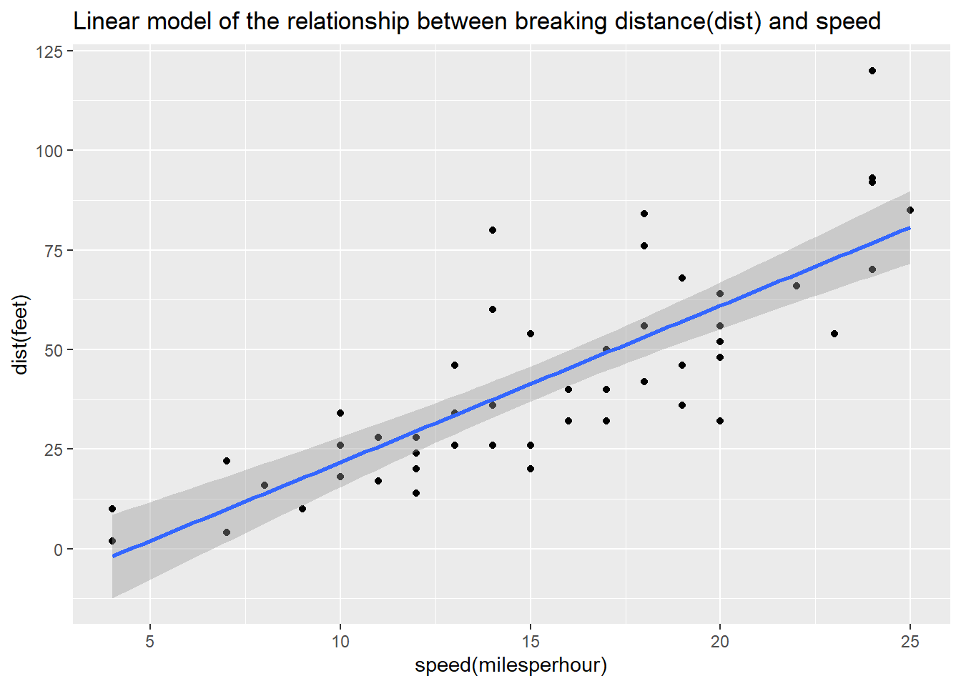

ggplot_new



Question 3.7. Again using the cars dataset, now use linear regression (lm) to estimate the average reaction time for the driver to start breaking (in seconds). To simplify matters you may assume that once breaking commences, breaking distance is proportional to the square of the speed. Explain the steps in your analysis. Do you get reasonable results? Finally, use ggplot to plot the data points and the fitted relationship.

model$residuals

## 1 2 3 4 5 6 7

## 3.849460 11.849460 -5.947766 12.052234 2.119825 -7.812584 -3.744993

## 8 9 10 11 12 13 14

## 4.255007 12.255007 -8.677401 2.322599 -15.609810 -9.609810 -5.609810

## 15 16 17 18 19 20 21

## -1.609810 -7.542219 0.457781 0.457781 12.457781 -11.474628 -1.474628

## 22 23 24 25 26 27 28

## 22.525372 42.525372 -21.407036 -15.407036 12.592964 -13.339445 -5.339445

## 29 30 31 32 33 34 35

## -17.271854 -9.271854 0.728146 -11.204263 2.795737 22.795737 30.795737

## 36 37 38 39 40 41 42

## -21.136672 -11.136672 10.863328 -29.069080 -13.069080 -9.069080 -5.069080

## 43 44 45 46 47 48 49

## 2.930920 -2.933898 -18.866307 -6.798715 15.201285 16.201285 43.201285

## 50

## 4.268876

View <- lm(dist ~ speed, data = cars)

model <- lm(dist ~ speed, data = cars)

summary(model)

##

## Call:

## lm(formula = dist ~ speed, data = cars)

##

## Residuals:

## Min 1Q Median 3Q Max

## -29.069 -9.525 -2.272 9.215 43.201

##

## Coefficients:

## Estimate Std. Error t value Pr(>|t|)

## (Intercept) -17.5791 6.7584 -2.601 0.0123 *

## speed 3.9324 0.4155 9.464 1.49e-12 ***

## ---

## Signif. codes: 0 '***' 0.001 '**' 0.01 '*' 0.05 '.' 0.1 ' ' 1

##

## Residual standard error: 15.38 on 48 degrees of freedom

## Multiple R-squared: 0.6511, Adjusted R-squared: 0.6438

## F-statistic: 89.57 on 1 and 48 DF, p-value: 1.49e-12

cars$residuals <- model$residuals

View(cars)

cars$spridicted <- model$fitted.values

predict(model, data.frame(speed = c(12.5, 15.5, 17)))

## 1 2 3

## 31.57601 43.37324 49.27185

predict(model, data.frame(speed = c(12, 15, 18)))

## 1 2 3

## 29.60981 41.40704 53.20426

ggplot <- ggplot(data = cars, aes(x= speed, y=dist)) + geom_point() + geom_smooth(method = "lm",formula = "y ~ x")

ggplot_new



#First: we have to idenify the variables: #breaking distance in miles = dist_m #one foot in miles = 0.000189394 #we have convert distance to miles #dist_m <- cars$dist*0.00018939 #Second: we have to idenify the variables: #speed in miles per hour = speed_m_h #the breaking distance is propotional to square of #the speed: speed_m_h <- cars $speed^2 #Now ready for the formula of linear model (lm): #lm(formula = dist_m ~ speed_m_h)

dist_m <- cars$dist*0.000189394

speed_m_h <- cars $speed^2

lm(formula = dist_m ~ speed_m_h)

##

## Call:

## lm(formula = dist_m ~ speed_m_h)

##

## Coefficients:

## (Intercept) speed_m_h

## 1.678e-03 2.443e-05

#since the distance and speed are constant and the #slope means half the reaction time, we have to #convert the reaction time in one hour to seconds: #1*60*60 = 3600 seconds #reaction_time <- 2.443e-05*2 #the slope reaction time is twice or double the #reaction time

reaction_time <- 2.443e-05*2

coverted_reaction_time <- reaction_time/3600

coverted_reaction_time

## [1] 1.357222e-08

#the results are not significant for the reaction #time and they are negative for the reaction time. #the results expected to be proportional and double #the value of the slope reaction_time

**library**(ggplot2)

plot_1 <- ggplot(data = cars, aes(speed_m_h, dist_m))+geom_point()

plot_2 <- plot_1 + geom_smooth(method = "lm", formula = dist_m ~ speed_m_h)

plot_3 <- plot_2 + ggtitle("Regression Model between Breaking Distance and Speed")

plot_3

## Warning: 'newdata' had 80 rows but variables found have 50 rows

## Warning: Computation failed in `stat_smooth()`:

## arguments imply differing number of rows: 80, 50

